Three states of Git:

Working directory

Staging area

Commit- Git Repository

Remote repository (GitHub)

Master branch

Git Installation: for Windows

Git-windows-64-bit

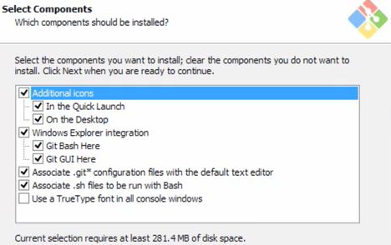

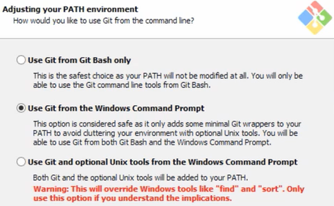

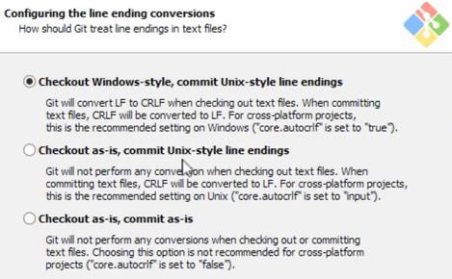

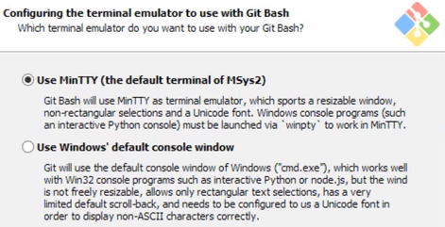

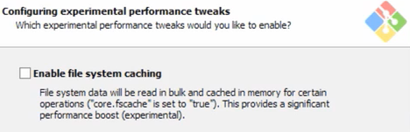

Basic Git Workflow

GitHub basic:

Create a GitHub repository online

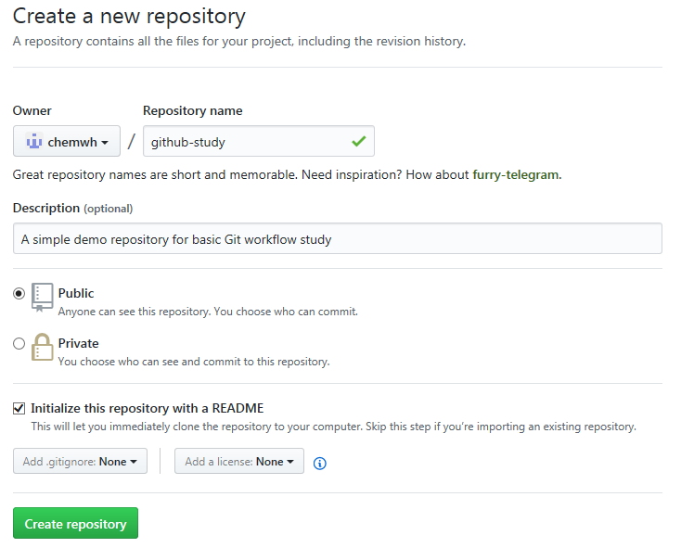

Preparing the local system for GitHub repository:

Create a folder:

pwd

mkdir projects

cd projects

Git Configuration:

git config --global user.name “Henry Wang”

git config --global user.email “henrywang10101@gmail.com”

git config --list

git config --global --list

Clone a repository:

In GitHub repository, click Clone or download, then copy the URL to clipboards

In Git Bash, make sure the pwd is projects fold:

git clone https://github.com/chemwh/github-study.git 【将GitHub的repo克隆到本地】

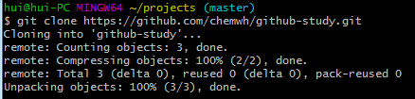

After done, check the status by ls

The first commit:

In Git Bash, make sure pwd is github-study:

echo “Test Git Quick Start demo”>>start.txt 【写一句话，并保存到新建立的文件】

Then use git status

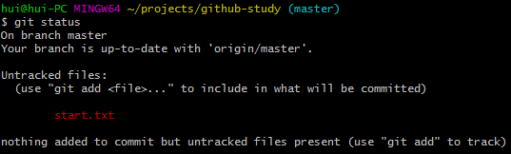

Then use git add start.txt



git status

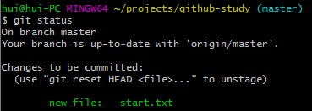

git commit –m “Adding start text file”

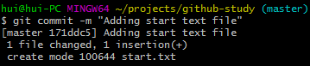

git status

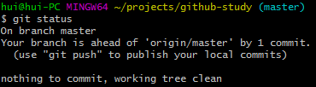

Pushing to GitHub:

Back to GitHub repository webpage, right click, and Refresh

Back to Git Bash

git push origin master

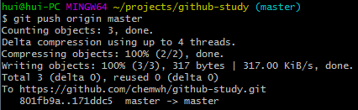

Back to GitHub repository webpage, right click, and Refresh again, you should see the file start.txt

Create a repository locally:

In Git Bash

git init new-repo

cd new-repo

in website: hipsum.co copy a sentence to clipboard

back to Git Bash

mate hipster.txt

Update a repository locally:”

In GitHub repository, click Clone or download, then copy the URL to clipboards

In Git Bash, make sure the pwd is in the repository need to be updated:

git pull https://github.com/chemwh/github-study.git master